Foundations Of Data Science Assignment #1 : Data exploration

Vishesh Kakarala

February 16, 2016

# Question 1

#### Part 1 :

The Office of Intergovernmental and External Affairs hosts ten Regional Offices that directly serve state and local organizations. Each Regional Director ensures the Department maintains close contact with state, local, and tribal partners and addresses the needs of communities and individuals served through HHS programs and policies. [link]<http://www.hhs.gov/about/agencies/regional-offices/>

#### Part 2:

**HHS region & states comparison**

library(XML)  
US.Flu.Data <- read.csv("C:/Users/Vishesh Kakarala/Desktop/Foundations of data science/HW 1/US Flu Data.csv")  
US.Flu.Data$Date = as.Date(US.Flu.Data$Date, format = "%m/%d/%Y")

**Comparison between HHS region 2 and states -New york & New Jersey**

In order to compare, we plot the data from the HHS region and the states data.

plot(US.Flu.Data$Date, US.Flu.Data$HHS.Region.2..NJ..NY.,main = "HHS region 2 Vs States", type = "p", col = "blue", pch = 20)  
points(US.Flu.Data$Date, US.Flu.Data$New.York, col = "yellow", pch = 20)  
points(US.Flu.Data$Date, US.Flu.Data$New.Jersey, col = "red", pch = 20)

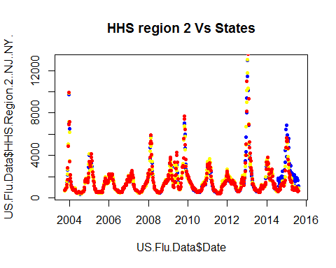

The states data is simlar to the HHS region except in the period from 2014 to 2016 where HHS region shows higher peak value and longer period of activity when compared to the state values.

A similar comparison can be done for another HHS region

**Comparison between HHS region 7 and State

plot(US.Flu.Data$Date, US.Flu.Data$HHS.Region.7..IA..KS..MO..NE.,main = "HHS region 7 Vs Iowa", type = "p", col = "blue", pch = 20)  
points(US.Flu.Data$Date, US.Flu.Data$Iowa, col = "red", pch = 20)

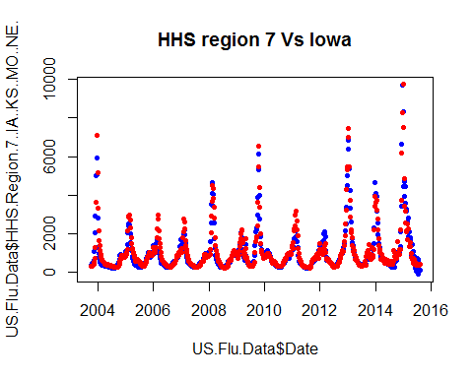

#### Part 3:

**Grouping cities as States**

State_cities <- data.frame(US.Flu.Data$Date)  
colnames(State_cities) <- "Date"  
State_cities$Date = as.Date(State_cities$Date, format = "%m/%d/%Y")  
  
State_cities$Alaska <- US.Flu.Data$Anchorage..AK  
State_cities$Alabama <- US.Flu.Data$Birmingham..AL  
State_cities$Arkansas <- US.Flu.Data$Little.Rock..AR  
State_cities$Arizona <- apply(US.Flu.Data[,67:71],1,function(x) mean(x,na.rm = TRUE))  
State_cities$California <- apply(US.Flu.Data[,72:82],1,function(x) mean(x,na.rm = TRUE))  
State_cities$Colorado <- apply(US.Flu.Data[,83:84],1,function(x) mean(x,na.rm = TRUE))  
State_cities$Florida <- apply(US.Flu.Data[,86:90],1,function(x) mean(x,na.rm = TRUE))  
State_cities$Georgia <- apply(US.Flu.Data[,91:92],1,function(x) mean(x,na.rm = TRUE))  
State_cities$Hawaii <- US.Flu.Data$Honolulu..HI  
State_cities$Iowa <- US.Flu.Data$Des.Moines..IA  
State_cities$Idaho <- US.Flu.Data$Boise..ID  
State_cities$Illinois <- US.Flu.Data$Chicago..IL  
State_cities$Indiana <- US.Flu.Data$Indianapolis..IN  
State_cities$Kansas <- US.Flu.Data$Wichita..KS  
State_cities$Kentucky <- US.Flu.Data$Lexington..KY  
State_cities$Louisiana <- US.Flu.Data$Baton.Rouge..LA

For comparing between the cities and states data we take an example of the state of Arizona and perform the comparison

summary(US.Flu.Data$Arizona)

## Min. 1st Qu. Median Mean 3rd Qu. Max.   
## 469 974 1676 2188 2477 20200

summary(State_cities$Arizona)

## Min. 1st Qu. Median Mean 3rd Qu. Max.   
## 579.3 1034.0 1699.0 2211.0 2528.0 18610.0

By comparing the Descriptive statistics we find that there are no missing values, and the data from the two columns have similar central tendency and distribution of data can be visualised using a boxplot

boxplot(US.Flu.Data$Arizona,State_cities$Arizona, names = c("Arizona","Cities Arizona"),horizontal = TRUE)

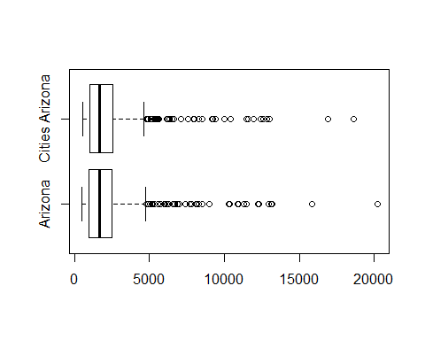 Using a box plot we can visually determine the distribution of data and median values of the two columns

When we compare data from the cities of Alaska and the data of the entire State of Alaska

summary(US.Flu.Data$Alaska)

## Min. 1st Qu. Median Mean 3rd Qu. Max. NA's   
## 538 908 1297 1619 1896 7384 63

summary(State_cities$Alaska)

## Min. 1st Qu. Median Mean 3rd Qu. Max. NA's   
## 547 938 1403 1683 2010 7566 55

we find that there is missing data in both the columns.

We can populate missing data using interpolation, here Spline Interpolation is used to predict the missing values

Alaska_interpol <- splinefun(US.Flu.Data$Alaska, y = US.Flu.Data$date, method = "periodic")  
US.Flu.Data$Alaska[1:63]<-Alaska_interpol(1:63)  
  
Alaska_cities_interpol <- splinefun(State_cities$Alaska, y = State_cities$date, method = "periodic")  
State_cities$Alaska[1:55]<-Alaska_interpol(1:55)

Natural Spline Interpolation is used because of the presence of one more cusps in the data,After we interpolate the missing data we can summarise the Data.

summary(US.Flu.Data$Alaska)

## Min. 1st Qu. Median Mean 3rd Qu. Max.   
## 538 884 1281 1601 1879 7384

summary(State_cities$Alaska)

## Min. 1st Qu. Median Mean 3rd Qu. Max.   
## 547.0 922.8 1384.0 1671.0 2010.0 7566.0

boxplot(US.Flu.Data$Alaska,State_cities$Alaska)

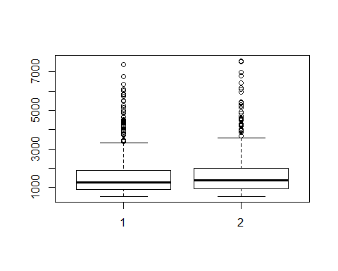 From the summary and the visual represntation we can find that the two columns of data have similar descriptive statistics.

#### Part 4:

**Design Two relevant Metrics**

First Metric : *Month Wise average Flu search activity*

Using this metric we can track which month has the highest Flu search activity from the period Dec'03 to Aug'15. This metric will aid in identfying the peak month of Flu activity and help understand seasonality of FLU trends in the geographical region. we can compare this data with the month wise heirarchial aggregates to understand Seasonal trends.

metric_1 <- data.frame(format(US.Flu.Data$Date, "%b"))  
aggregate_metric <- aggregate(US.Flu.Data[,2:53],list(month=metric_1$format.US.Flu.Data.Date....b..),mean,na.rm = TRUE)   
frame()  
plot(aggregate_metric$month, aggregate_metric$Oklahoma,main = "Monthly Aggregate",n= 1500,col = "blue", pch = 20)  
points(aggregate_metric$month, aggregate_metric$California, col = "red", pch = 20)

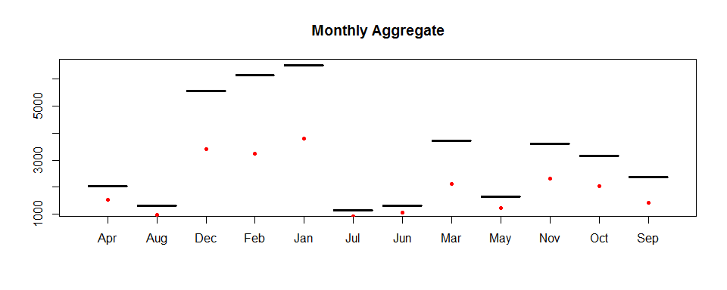 While Jan and Feb are the seasonal months in Oklahoma, it is Dec and Jan in California

Second Metric : *weekly rate of Change*

This metric aids in understanding the movement of Flu trends on a weekly or monthly basis.

Here we calculate weekly rate of change in the latest Year for the state of California

weekly_change <- data.frame(c(1:32))  
for(i in 1:32)  
{  
   
 weekly_change[i,1]<- ((US.Flu.Data$California[i+588]- US.Flu.Data$California[i+588-1])/US.Flu.Data$California[i+588-1])*100  
   
}  
  
weekly_change$date <- US.Flu.Data$Date[589:620]  
plot(weekly_change$date,weekly_change$c.1.32., type = "l")

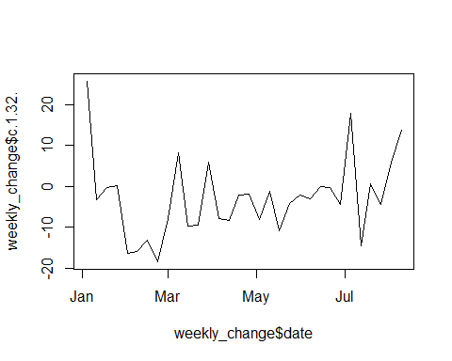

The plot shows the rate of change by months for the latest year in california, we can also calculate this information in a year wise distribution to understand changing trends.

#### Part 5

Population data - [link]<http://www.census.gov/popest/data/state/totals/2015/index.html>

population_data <- read.csv("~/learning test/NST-EST2015-01.csv")  
US.Flu.Data.2015 <- US.Flu.Data[589:620,]   
flu_max_2015 <- data.frame(apply(US.Flu.Data.2015[,3:53], 2,function(x) max(x)))   
flu_max_2015$population <- population_data$Population.estimates.2015  
colnames(flu_max_2015) <- c("Peak_2015","Population_2015")

For Two Continous variables linear regression test is done to reject or fail to reject a null hypothesis

significance.lm <- lm(flu_max_2015$Population_2015 ~ flu_max_2015$Peak_2015, data = flu_max_2015)  
summary((significance.lm))

##   
## Call:  
## lm(formula = flu_max_2015$Population_2015 ~ flu_max_2015$Peak_2015,   
## data = flu_max_2015)  
##   
## Residuals:  
## Min 1Q Median 3Q Max   
## -5948932 -4359422 -1529357 685357 32928624   
##   
## Coefficients:  
## Estimate Std. Error t value Pr(>|t|)   
## (Intercept) 7239635.1 3342415.6 2.166 0.0352 *  
## flu_max_2015$Peak_2015 -174.2 591.8 -0.294 0.7697   
## ---  
## Signif. codes: 0 '***' 0.001 '**' 0.01 '*' 0.05 '.' 0.1 ' ' 1  
##   
## Residual standard error: 7268000 on 49 degrees of freedom  
## Multiple R-squared: 0.001766, Adjusted R-squared: -0.01861   
## F-statistic: 0.08667 on 1 and 49 DF, p-value: 0.7697

Here since p value is 0.797 , we fail to reject the null hypothesis and the result is statistically not significant

We analyze the scatter plot

plot(flu_max_2015$Peak_2015,flu_max_2015$Population_2015, main = "Population Vs Peak Flu trend value", xlab = "Peak flu Trend 2015", ylab = " Population 2015")

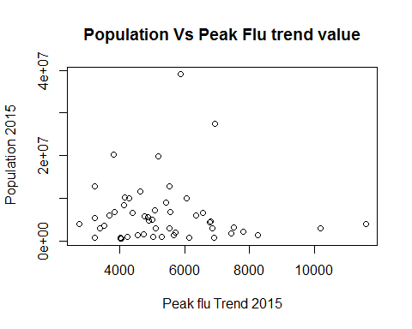

From the scatter plot it is clear that higher population does not mean higher peak Flu trend value

cor(flu_max_2015$Peak_2015,flu_max_2015$Population_2015)

## [1] -0.04202087

The correlation coefficient is negative i.e Peak flu value does not increase with increasing population

# Question 2

Source for Country wise central latitude [link]<https://developers.google.com/public-data/docs/canonical/countries_csv>

world_data <- read.csv("~/learning test/world_data.csv")  
world_data_2015 <- world_data[628:659,]  
flu_max <- data.frame(apply(world_data_2015[,2:30], 2,function(x) which.max(x)))  
rownames(flu_max) <- colnames(world_data_2015[2:30])  
colnames(flu_max) <- "Max_flu"  
flu_max$Max_flu <- world_data_2015[c(flu_max$Max_flu),1]  
flu_max$Max_flu = as.Date(flu_max$Max_flu, format = "%m/%d/%Y")  
  
world_lat <- read.csv("~/learning test/world_lat.csv")  
  
rownames(world_lat) <- world_lat$name  
  
rownames(flu_max)[16]<- "New Zealand"  
rownames(flu_max)[28]<- "United States"  
rownames(flu_max)[23]<- "South Africa"  
  
flu_max$latitude <- world_lat[match(rownames(flu_max),rownames(world_lat)),]$latitude  
  
plot(flu_max$Max_flu,flu_max$latitude, main = "Max week of Flu in 2015 Vs Central Latitude of countries",xlab = "Central Latitude", ylab = "Max week of Flu in 2015", type = "p", col = "blue", pch = 20)  
text(flu_max$Max_flu,flu_max$latitude,labels = row.names(flu_max),pos = 1)

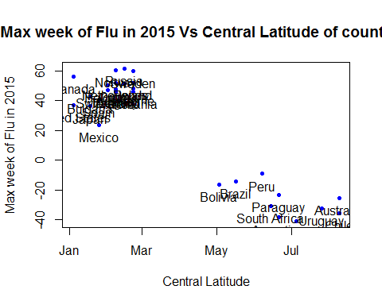

It is clear from the graph that Flu search trends are seasonal depending on the position of the countries latitude above or below the equator. With flu search trends increasing in the peak winter season in the northern hemisphere and in the peak summer months in the southern hemisphere.

# Question 3

#### Part 1:

**Reading vaccine status Data**

test_table <- readHTMLTable("http://www.cdc.gov/mmwr/preview/mmwrhtml/mm6401a4.htm?s_cid=mm6401", header = TRUE, trim = TRUE)  
table1 <- data.frame(test_table$`table-3`)  
table1 = table1[-(1:3),]  
table1 = table1[-38,]  
colnames(table1) <- c("charecteristics","Influenza_positive_no","Influenza_positive_%","Influenza_negative_no","Influenza_negative_%","Test_result_P_value","vaccinated_status_no","vaccinated_status_Total","vaccinated_status_%","vaccinated_status_pvalue")  
rownames(table1) <- table1[,1]  
table1<-table1[,-1]

#### Part 2:

**Example of a similar table**

Table showing Drug overdose and deaths by by sex, age, race and Hispanic origin, Census region, and state —United States, 2013 and 2014 From CDC's morbidity and mortality report(MMWR)-[link]<http://www.cdc.gov/mmwr/preview/mmwrhtml/mm6450a3.htm?s_cid=mm6450a3_w>

table_2 <- readHTMLTable("http://www.cdc.gov/mmwr/preview/mmwrhtml/mm6450a3.htm?s_cid=mm6450a3_w")  
table_2 <- table_2$`table-4`